Alex Dote, Jack Smith, Mike McQuade

**User Guide**

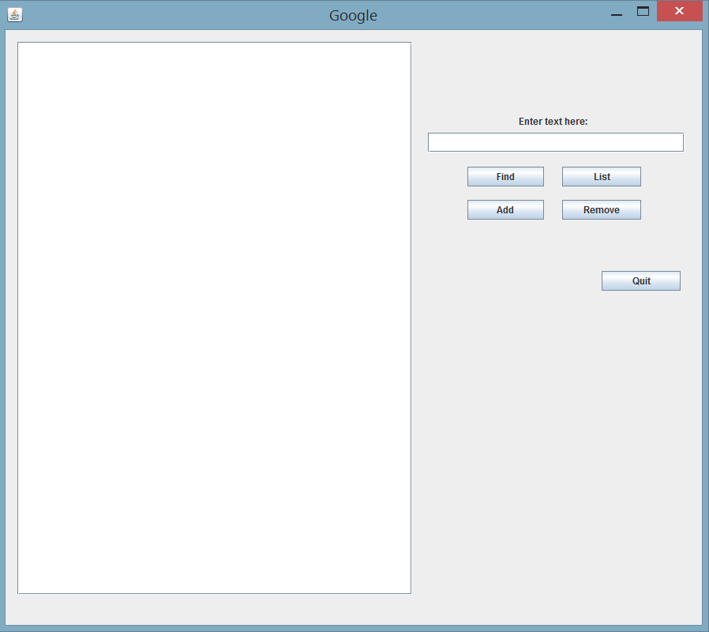The project must first be loaded in a project file in eclipse and stored in the package edu.canisius.search. From there the user can compile and run the GoogleGUI java class, which will open the GUI below. The user can type a URL in the text box and click “Add” in order to save a URL into the database, including all values associated with the URL. The “List” button displays all URLs that a given keyword is found on, and the “Find” button displays the location of a certain keyword that is typed into the text field, including if it occurs multiple times, and how many times it appears. The “Remove” button will erase a URL and all associated values from the Map structure that stores the URLs and their values, and to make it easier for the user, the text area has a highlight functionality wherein the user can copy and paste a URL over from the text area into the text field.